**How to setup a Jenkins production and testing pipeline using docker??**

Assumptions: Jenkins And Docker are installed in RHEL OS

Jenkins is added in sudoers file.

User has a Github Profile and Git Bash is Installed

1. Create a folder on your preferred place

2.Create a index.html file and write something it .

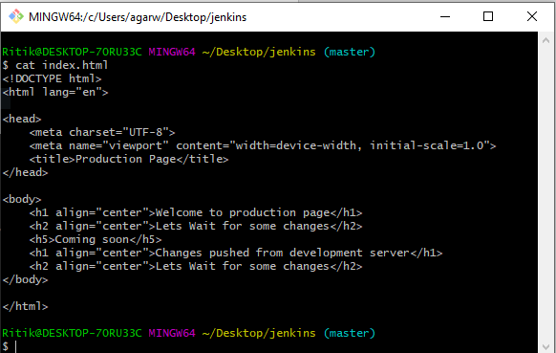

This is my Index.html file for testing

3.Open Git bash where your file is located

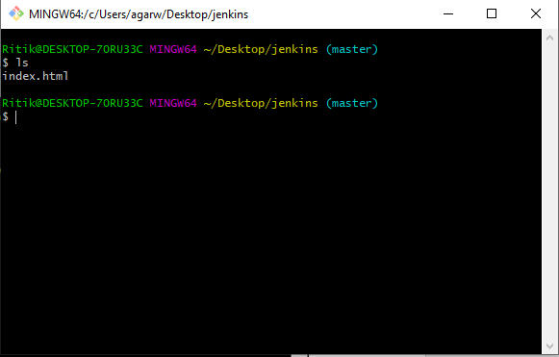

4. Create a git repository

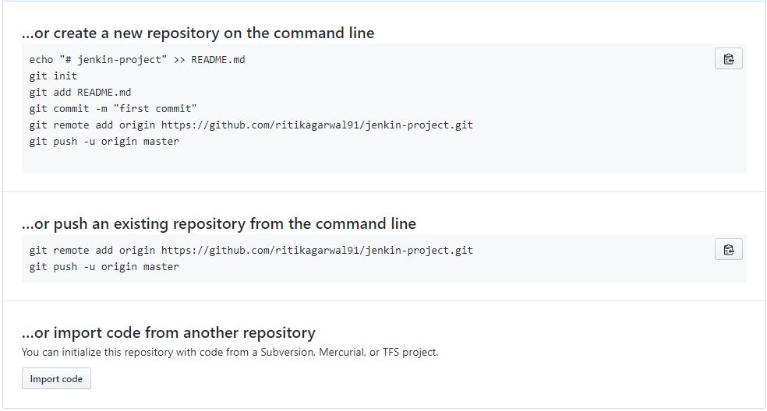

5.Paste the command on the git terminal you opened in previous step(step 4)

6. Now create development branch by typing:

Git branch development

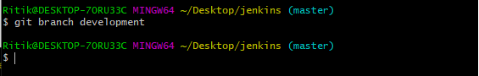

To check this branch type git checkout <branchname>

Here my branch name is developer



Screen will look something like this



7. Edit the code in this branch

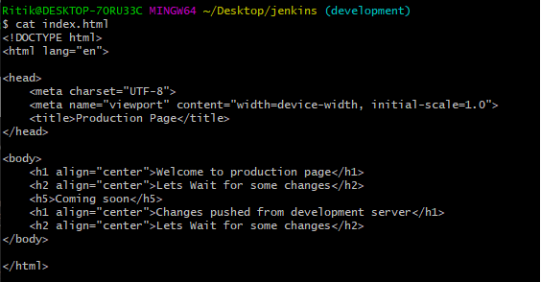

8. Add and commit the code

Git add.

Git commit -m “message“

Git checkout master

9. Git push –all

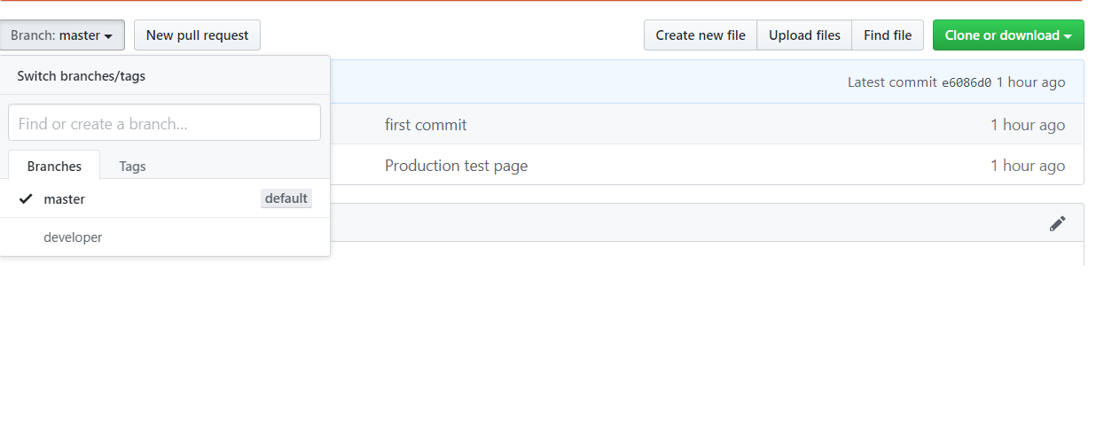

PART 2

Now we need to setup Jenkins for the job

Fire up Jenkins

I will be doing the this task in 4 Steps

Step 1:

Create Job1 with following configuration

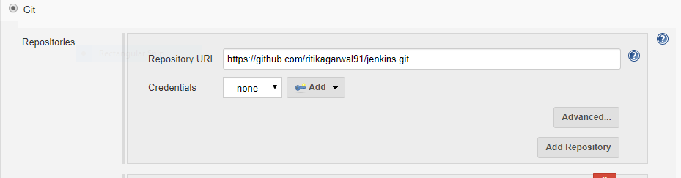

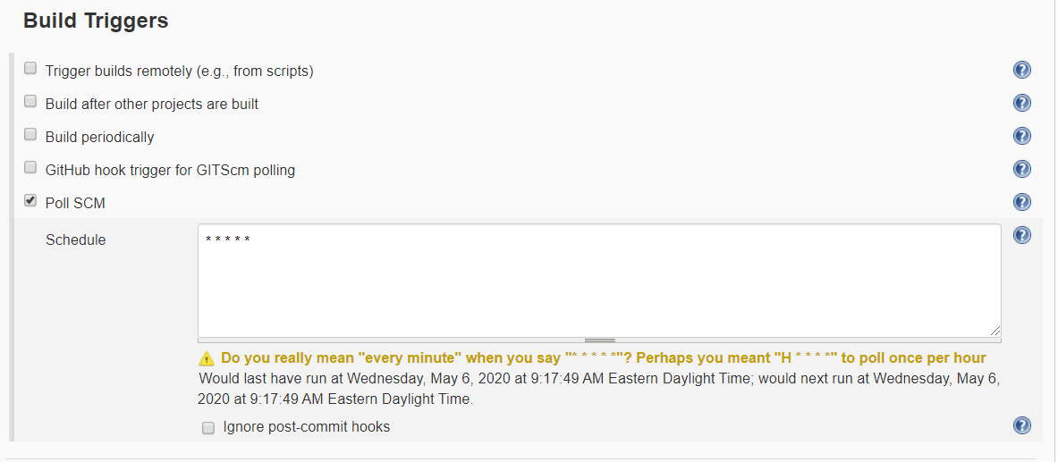

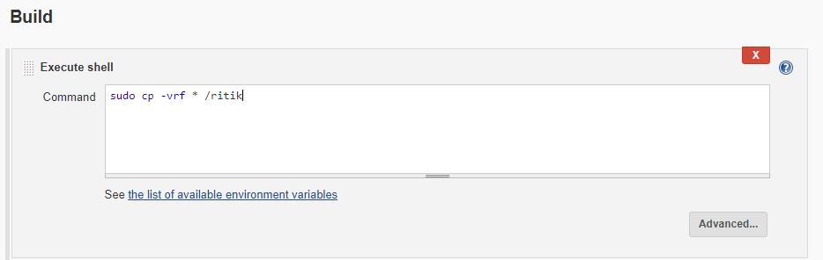

Save the job

STEP 2:

Create another job for production server



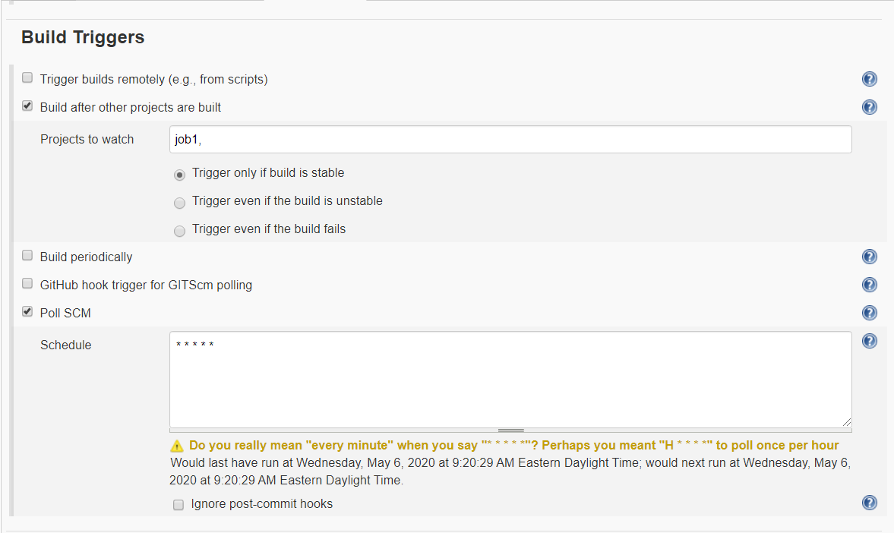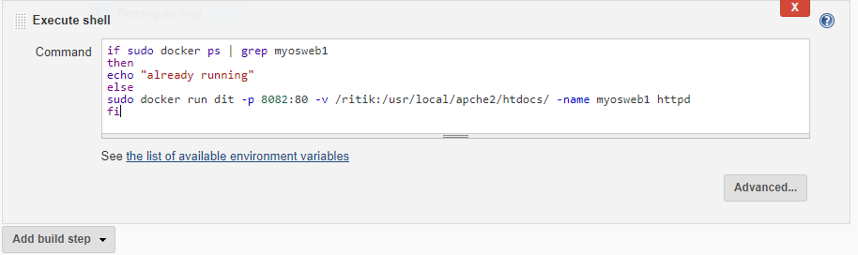

Save the job

STEP 3

For Development Environment

Create a job name gitup-test.



#NOTE REPLACE the master with your development branch



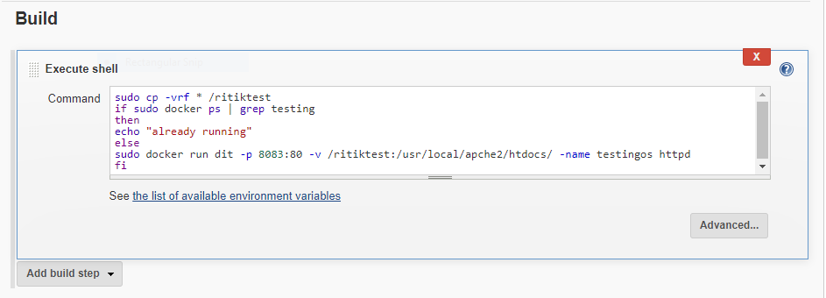

Step 4

Create a job QA-approved

# go to advanced post build section

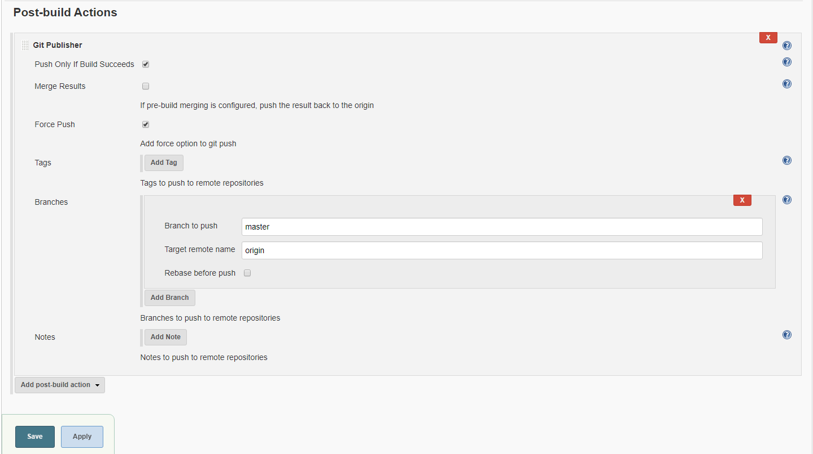

YOU ACHIEVED IT

This is how the index page in branch looks

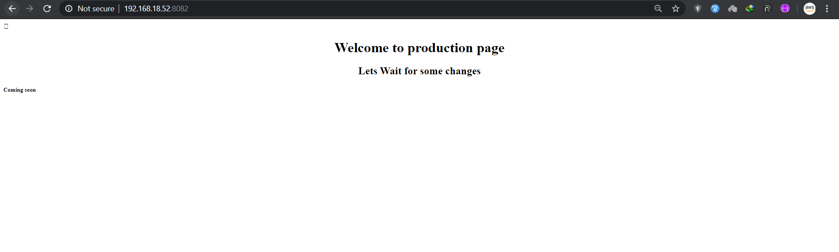

This is what development server looks like

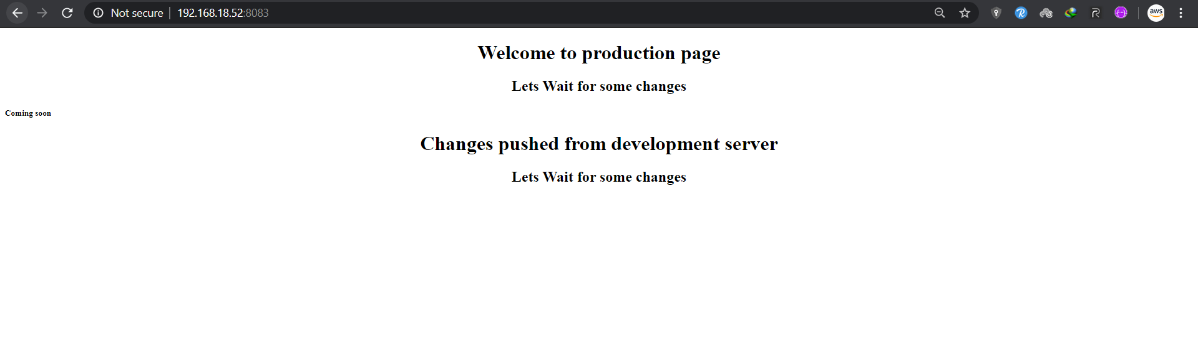

Once the QA team test the code they will start the QA-test job white we configured at PART2:STEP 4



This will update the Ip you can also the jobs using HOOKS

This is what Docker looks like after this process

